# System Architecture

The Alpha Car Hire is a web-based system that allows different functionalities depending on who is using it. There will be dashboards for administrators and customers, after login where they can perform their required actions. This system allows administrators and moderators to display all vehicles available for rent and monitor any rented vehicle associated with any customer. For each beneficial necessity, the expert system consumes attention UI organizations and grants administrators and moderators to make authorized changes in the system for example adding or removing vehicles. Car owners simply can add vehicles and its details to the system after becoming members. Customers are able to see the available vehicles with details at one place and can select date and time for pick and drop of rented car after making account or login.

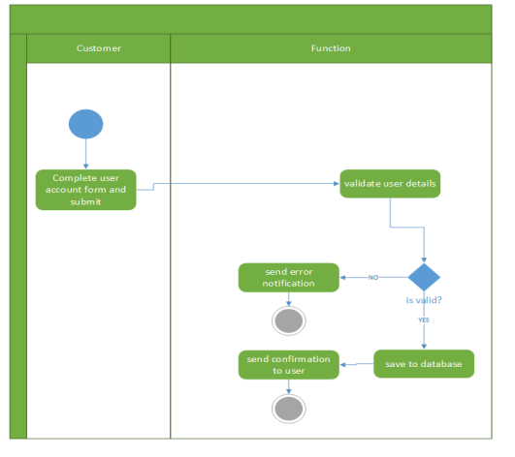

For maintaining privacy and good performance this system only shows the results which are need to the user for instance, it will not display the car owner details with the cars searched by customer and it only understands what portion to consume and coordinate for explicit convenience in the necessary needs. Downstream components such as the specialist list, provider profile, vehicle, and so on are behind the project structure transport and are unconditionally piled in the project stack within the holder. Information provider transit illustrates data providers, while data access is provided by firms that just supply CRUD functions (Xue & Luo 2018).

# Software and hardware Architecture Design

Reps may quickly manage arrangements, instalments, car troubles, and SMS notifications to clients with the help of this MVC framework. Administrator can contribute new data, edit or remove currently available vehicles, and that's just the top of the iceberg. As a result, there is no delay in the accessibility of any information, and any critical information may be restored quickly and without difficulty. For the purpose of security, all clients should create another record before checking in; otherwise, they will wish to access the structure with their created record and make a stopping reservation. At that point, the client will be notified through SMS of the vehicle's availability. To encourage the web-based structure and SMS notification, the Software Development Life Cycle (SDLC) was employed. SDLC is a framework that illustrates all types of developments and cycles in a product development process. Self-driving projects make use of a combination of these equipment components. The goal of driving assistance frameworks is to work on the security of the vehicle's inhabitants as well as the general wellness of the environment, while furthermore increasing the driver's comfort.

## Context diagram

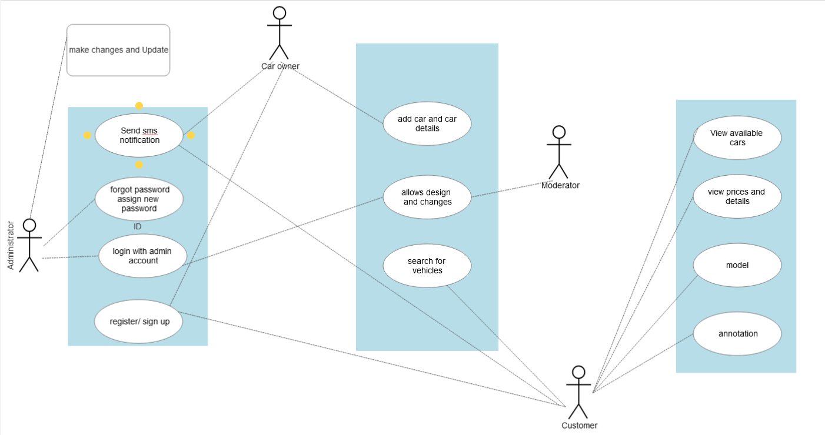

# Appendix

Car Rental Portal Management System is a web-based system for an Alpha Car Hire company which rents out cars to the customer. This system is developed to help the company which make their services available to the customer via internet and also keep records of every customer, vehicle, ride history, etc. This business provides short-term car rentals for a few days or a week. To expand their business and make popular this business is transformed in web based online portal from which everyone can have access to rent or hire the car. This will help customer and company in many ways. This system makes the renting of cars very easy which will save time and labour. Customer can choose the cars they want according to their need and requirement. The admin of the system registers the staff and driver or car owners but client can be register by themselves. The customer can use the internet to log into the system after registering. The customer can then select the car and make their selection based on their needs. Then, other processing will be done and notification will be sent to the car owners and admin (Firsthand, 2022).

The project may take a little while for completion of the overall system of Alpha car Hire Car Rental Portal Management System. Below given is the Gantt chart for the project completion of this system.

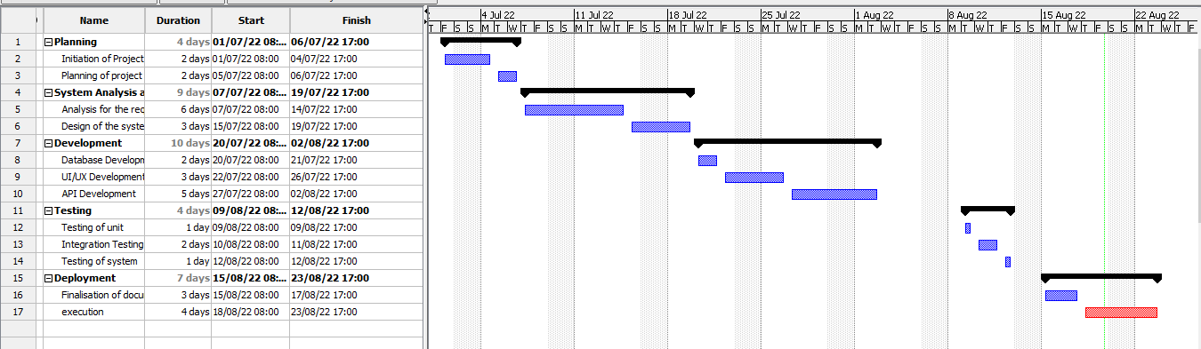

the budget estimation for Alpha car Hire Car Rental Portal Management System:

|  |  |
| --- | --- |
| Task | Required Budget |
| Planning for the project | $10,000 |
| Analysis of the project | $15,000 |
| Designing of the project | $30,000 |
| Implementation of the project | $35,000 |
| Testing performance | $20,000 |
| Review and maintenance | $10,000 |
| Total | $1,20,000 |

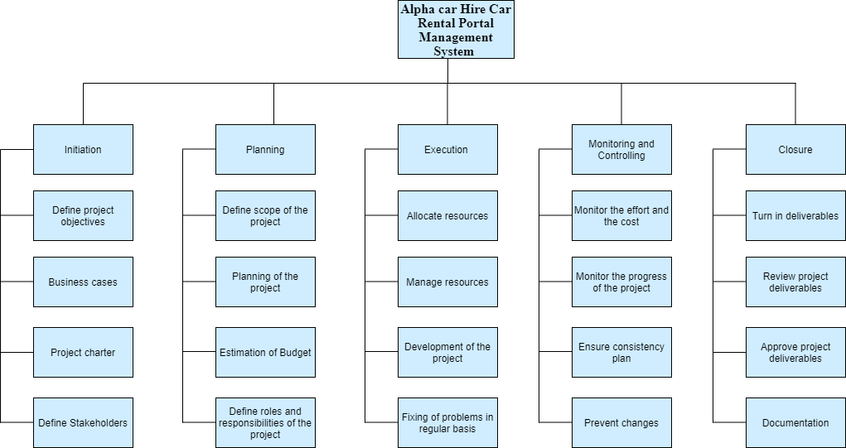

Functional requirements are what a software system must do: its features and functions.

|  |  |  |
| --- | --- | --- |
| **FR.no** | **Functional requirements** | **Comments** |
| FR1 | Customer registration | Login system and this will be skipped if customer is already registered.  The user has 2 ways to register physically and online.  the online form must be verified by the client uploading their ID , birth certificate, or any credentials that will validate their identity, for this process We are using salt with hash php function ,  $user =$_post['user_input'];  $result = hash("sha256" , $user);  In this way we will encrypt the user's password and validate all the data with sanitization of all the inputs |
| FR2 | Forgot password | we will use an input where the user will be asked for the email and we will send an email to his email after verifying if the user exists,  input and button form to recover the password are using encryption SHA256 with hash and salt |
| FR3 | Search for available vehicle | Search car by their ID , model , color , capacity , etc, all of them are input which come from the user upload and the input names must be the same as the database |
| FR4 | View vehicle with details | Once customer found the vehicle we will create dynamic Single product page in which will be using global variable $_POST PHP to identify the id product page |
| FR5 | Product catalog | The product catalog will be organized by categories car (cars, sedan,suvs trucks) which one will have category ID |
| FR6 | Payment mode | This payment module will give the option to pay with bankwire , paypal and offline credit card |
| FR7 | Calculate cost | The calculate total cost is doing by our class Payment that has functions to validate the payment |
| FR8 | E- payment | We will include Paypal and apple wallet |
| FR9 | Reserve vehicle for renting | This reserve will be working with 2 important php fundamental PHP elements like date and objects date will be storage in the mysql database |
| FR10 | Feedback from customer | for the feedback we will use a module that will allow us to leave a review of the user and product and company, which must be moderated by the web master and this will be Integrated through javascript to Google merchant center through the API and this will allow us to show our stars in google adwords ads. |
| FR11 | Add new vehicle/ vehicle category | Each user will be allow to add new vehicle if this is beetween our categories and the system will check add the new vehicle with a new ID which is automatic generated in order |
|  | Update vehicle details | Same as add the system will check our booking system doing a query to the database with php, our schedule and calendar with date() |
|  | Change vehicle status | this will allow the customer to modify the vehicle and make it available or unavailable and all this will be verified by our dates in the database and the input ID will be used to update each vehicle |
|  | Remove vehicle/ vehicle category | The user has the option to delete the car with a button that will delete the vehicle ID within the account on the client side and this way it will not be displayed on the front end |
|  | Send availability via text message | We collect user phone number from form registration and If the user authorized us we will send a text message when the vehicle they want is available |
|  | Database management | Mysql Database will be manage by database specialist and it will use the CRUD system, that will update each user vehicle. |
|  | Payment management | The payment management will record each transaction and send the money to the client where a fee will be charged to the user by our company.  will be connect to our reckon accounting software with an API and the manager will be do it by sales employees |
|  | Admin dashboard | Admin dashboard will be very easy to use.  Will allow to manage payments , add , edit and remove produ0cts and customers , edit content , prices etc. |
|  | Car gallery | the user will upload images to the web through a form that will use a tag in the html form like this enctype="multipart/form-data" , this allows uploading files with php to the database and in this way the images will be displayed to the gallery |
|  | Booking cancelation | The cancellation of the reservation will be through a PHP form connected to our calendar and database that will again use the most important input, which is the ID input. |
|  | Customer dashboard | Will show the car they have rent and their customer history, Develop with html css, php and javascript in front and back end |
|  |  |  |

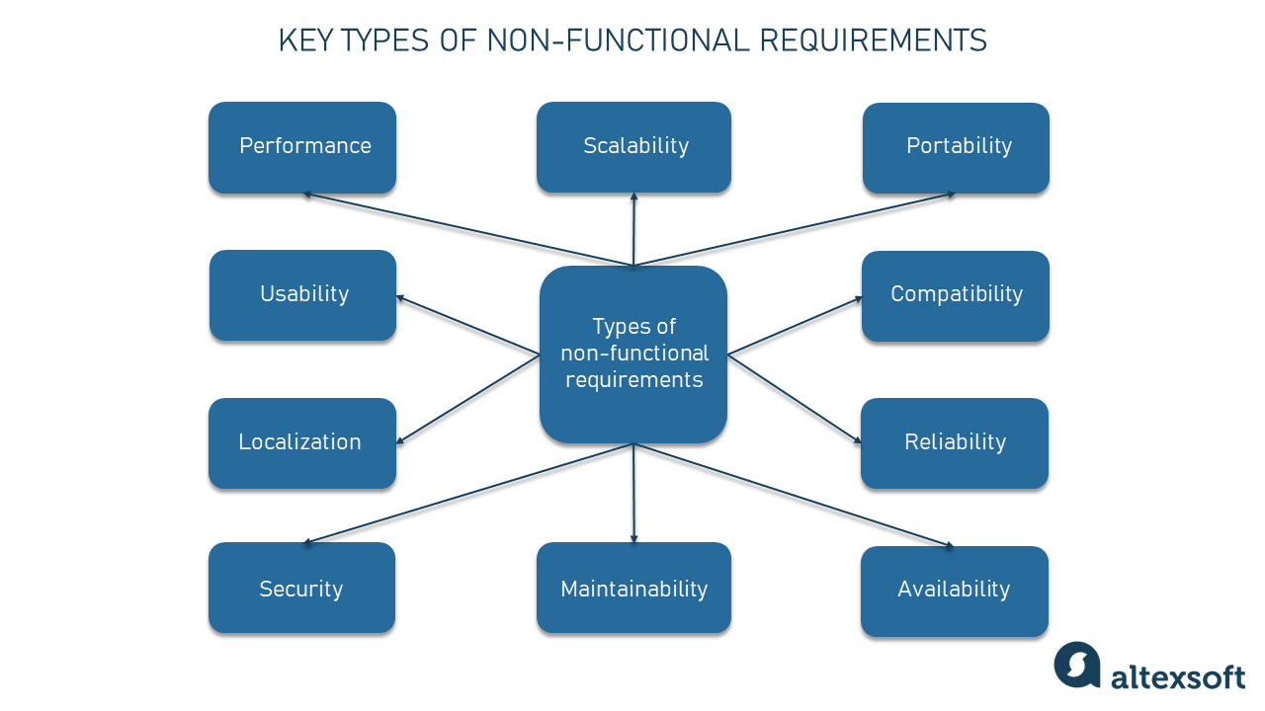

Figure 1: Use Case Di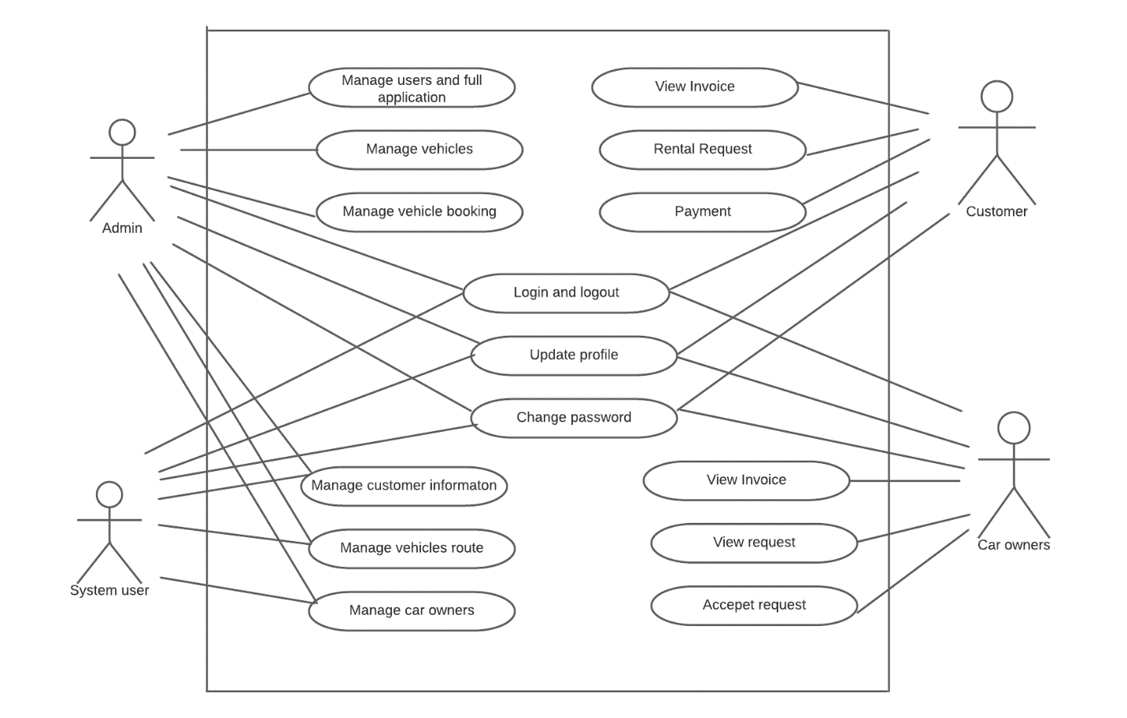agram

**DFD Diagram**

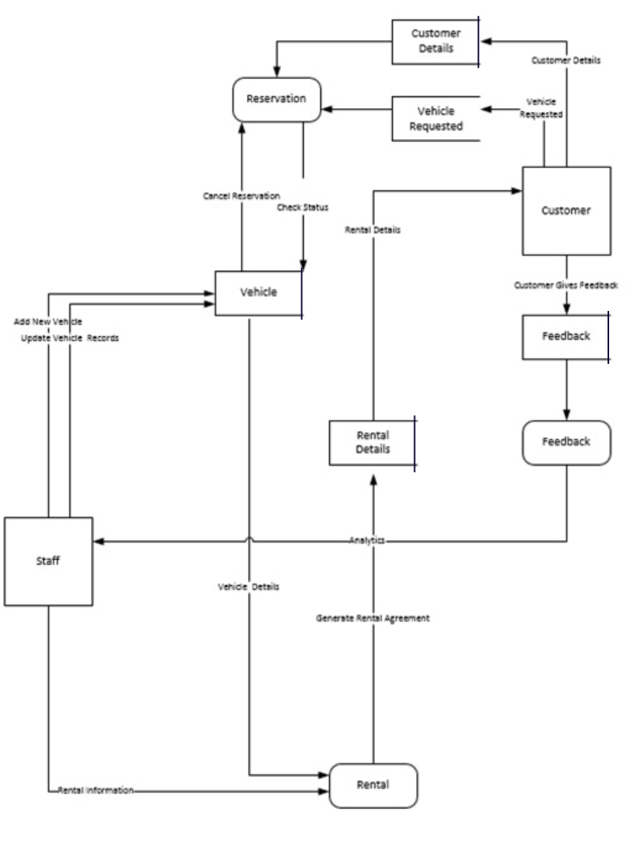

**System Design**

**User Interface**

**Sequence Diagram**

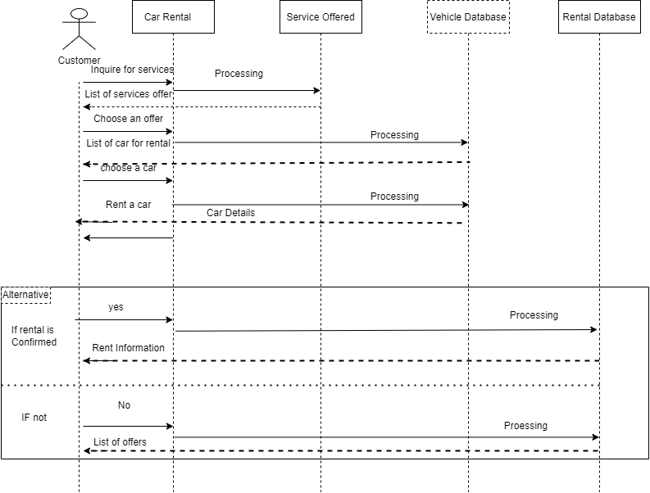

**ERD**

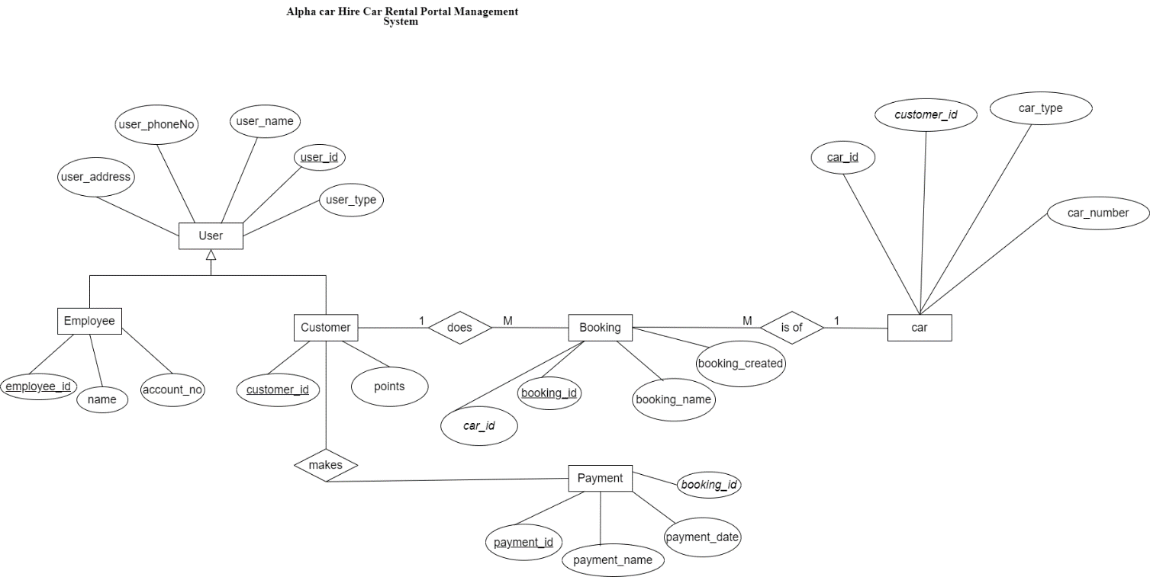

**Data Dictionary**

User record

|  |  |  |  |
| --- | --- | --- | --- |
| Name of field | Size | Data Type | Description |
| user_id | 15 | int | User_id can be considered as the primary key for the database table user. |
| User_phoneNo | 255 | varchar | Name of the user |
| user_name | 255 | varchar | Phone no of the user. |
| user_address | 255 | varchar | Address of the user |
| user_type | 255 | varchar | Type of the user |

Customer record

|  |  |  |  |
| --- | --- | --- | --- |
| Name of the field | Size | Data Type | Description |
| customer_id | 15 | int | customer_id can be considered as the primary key for the database table user. |
| points | 15 | double | Name of customer |

Employee record

|  |  |  |  |
| --- | --- | --- | --- |
| Name of the field | Size | Data Type | Description |
| employee_id | 15 | int | employee_id can be considered as the primary key for the database table user. |
| name | 255 | varchar | Name of the employee |
| account_no | 255 | varchar | Account no of employee where their salary goes. |

Car record

|  |  |  |  |
| --- | --- | --- | --- |
| Name of the field | Size | Data Type | Description |
| Car_Id | 15 | int | car_id can be considered as the primary key for the database table user. |
| Customer_id | 255 | varchar | Foreign key with reference to customer table in database. |
| Car_number | 255 | varchar | Number of the car. |
| Car_Type | 255 | varchar | Type of the car. |

Booking Record

|  |  |  |  |
| --- | --- | --- | --- |
| Name of the field | Size | Data Type | Description |
| Booking_id | 15 | int | booking_id can be considered as the primary key for the database table user. |
| booking_Name | 255 | varchar | The name booking is made in. |
| car_id | 15 | int | Foreign key with reference to car table in database. |
| Booking_created |  | bool | For the confirmation of booking. |

Payment record

|  |  |  |  |
| --- | --- | --- | --- |
| Name of the field | Size | Data Type | Description |
| payment_id | 15 | int | payment_id can be considered as the primary key for the database table user. |
| payment_name | 255 | varchar | The name payment is done with. |
| payment_date |  | date | Date when the payment was done. |
| Booking_id | 15 | int | Foreign key with reference to booking table in database. |